Assignment 3 Brief

|  |  |
| --- | --- |
| **Product Name** | Applied Degree in Software Engineering (BDSE) |
| **Qualification Name** | Applied Degree in Software Engineering/ Higher Diploma in Software Engineering |
| **Assignment Title** | Project Proof Of Concept (POC) |
| **Module Name (BDSE)** | Develop Enterprise Applications |

|  |  |
| --- | --- |
| **Student Name** | **Mentor Name** |
| **Wildan Luqmanul Hakim** | Arvinder Kaur |

|  |  |
| --- | --- |
| **Project Title** | Meals on Wheels Software Design Document. |

|  |
| --- |
| **Learner declaration** |
| I certify that the work submitted for this assignment is my group work, and research sources are fully acknowledged.      Student signature: Date: January 30, 2023 |

**Status :** In Progress

**Stakeholder :** Merry Meal

**Manager :** Mr. David.

**Project Lead :** Arvinder Kaur

**Project Member:**

* [Wildan Luqmanul Hakim](mailto:WildanLuqmanul@gmail.com)
* [Bagus Nanda](mailto:gusnanda0703@gmail.com)
* [Steffansim](mailto:steffansim@gmail.com)
* [Norman Tseu](mailto:normantmhwork@gmail.com)

**Purpose of this Assignment is used for the following:**

Formative Assessment of learners in the Module ‘Develop Enterprise Applications’ of the Course ‘Applied Degree in Software Engineering’.

**Assignment Assumptions**

You can make following assumptions while implementing the assignment:

This assignment is not for commercial use and hence not fine-tuned for performance, but it is desirable that you focus on performance issues and address them, if any.

**Assignment Guidelines**

You should follow the below guidelines while implementing the Assignment. Learners are required to:

* Develop a POC of the application
* Refine the design document

## **Use Case Diagram**

## Use-case diagrams describe a system's high-level functions and scope. These diagrams also show how the system and its actors interact with one another. In use-case diagrams, the use cases and actors describe what the system does and how the actors interact with it, but not how the system operates internally.

## 

## 

## **Project Prototype -** View Flow of the Prototype Here: <https://www.shorturl.at/aFVZ7>

Landing Page

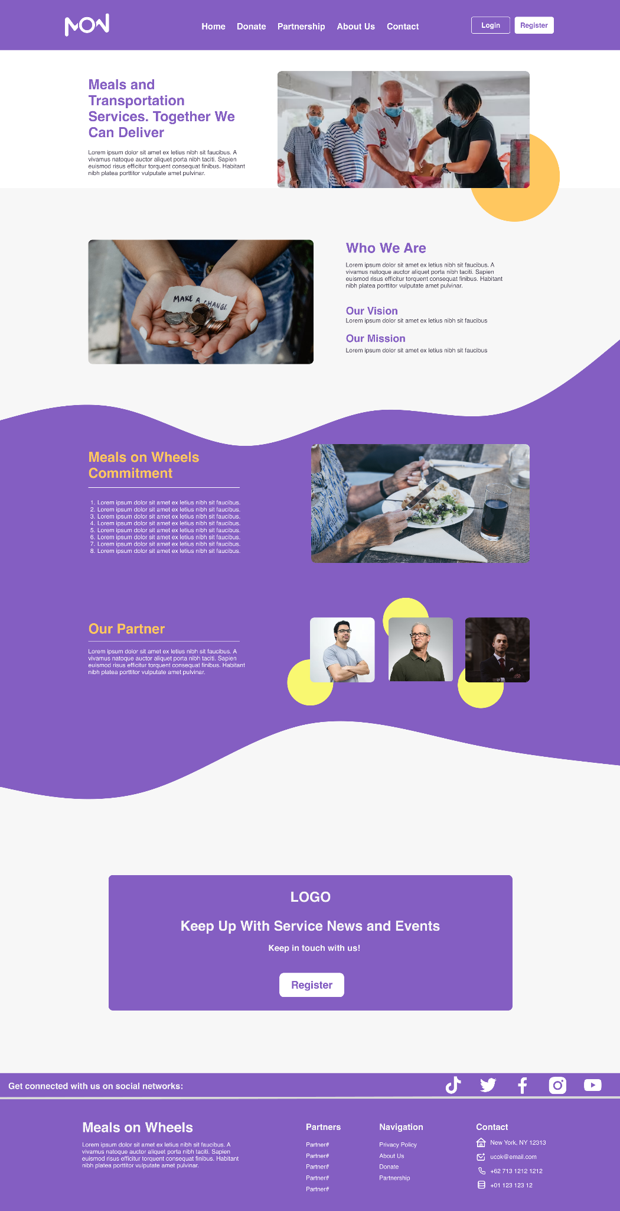

Register Page

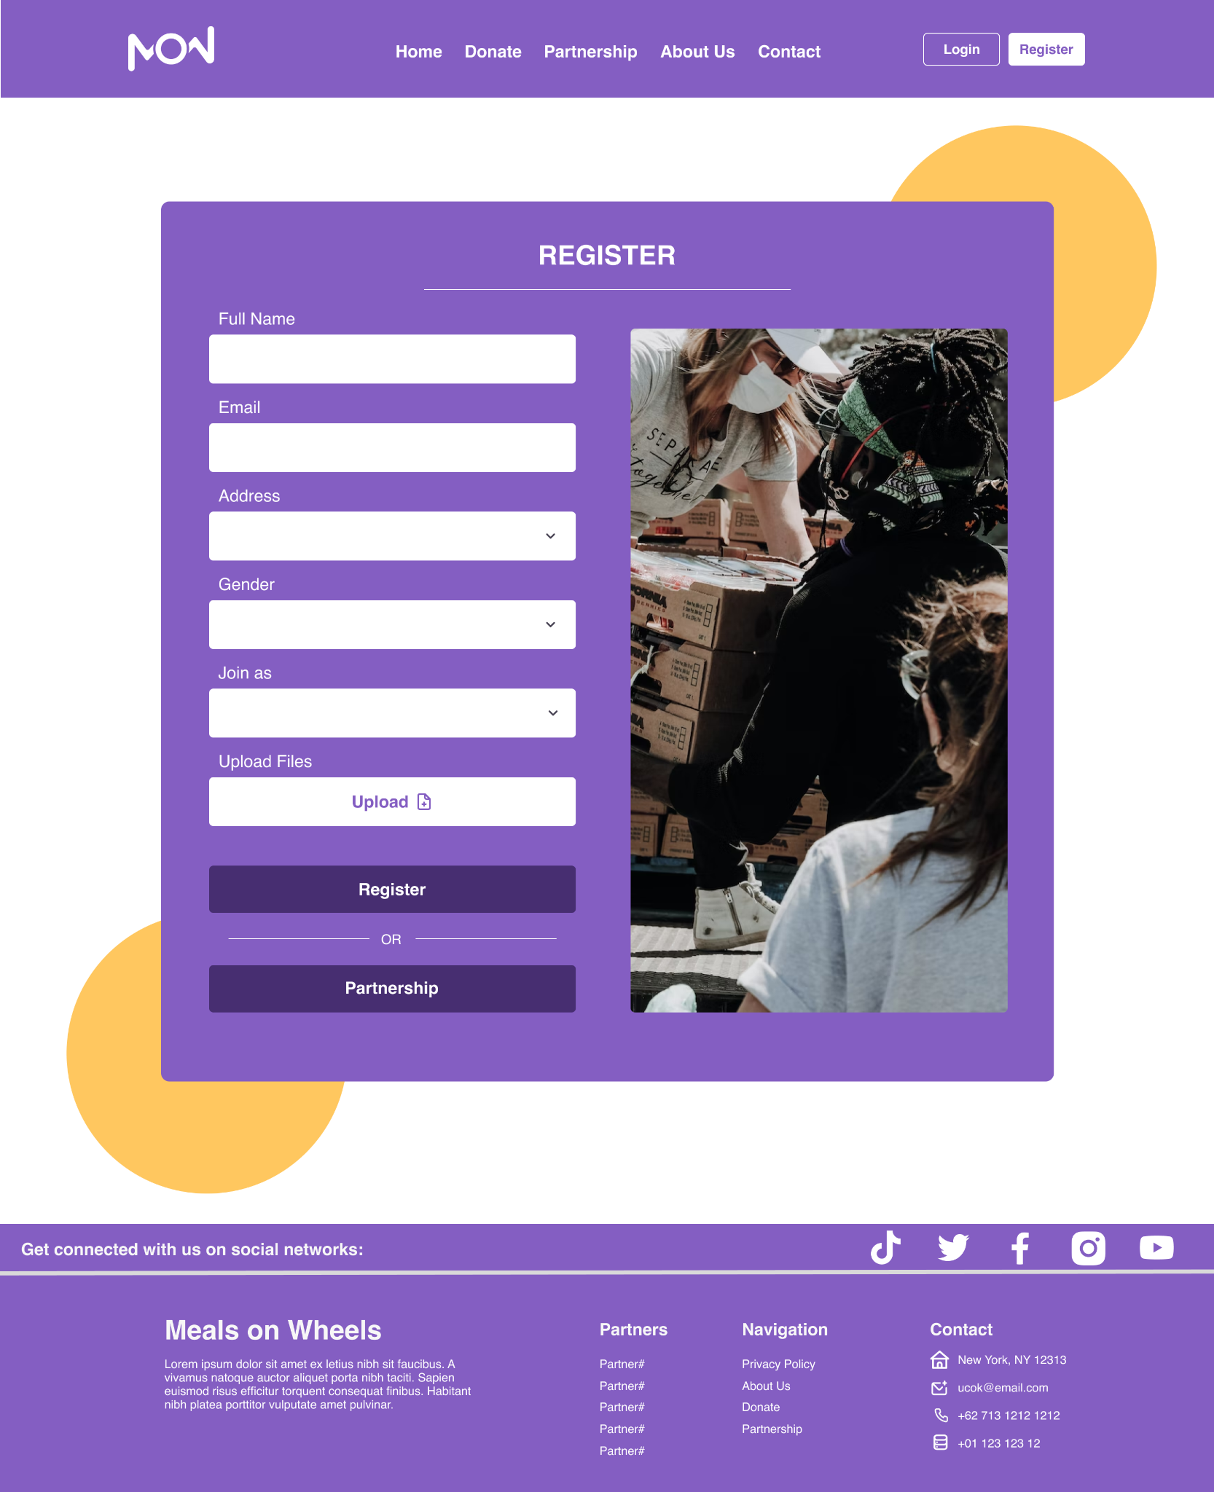

Login Page

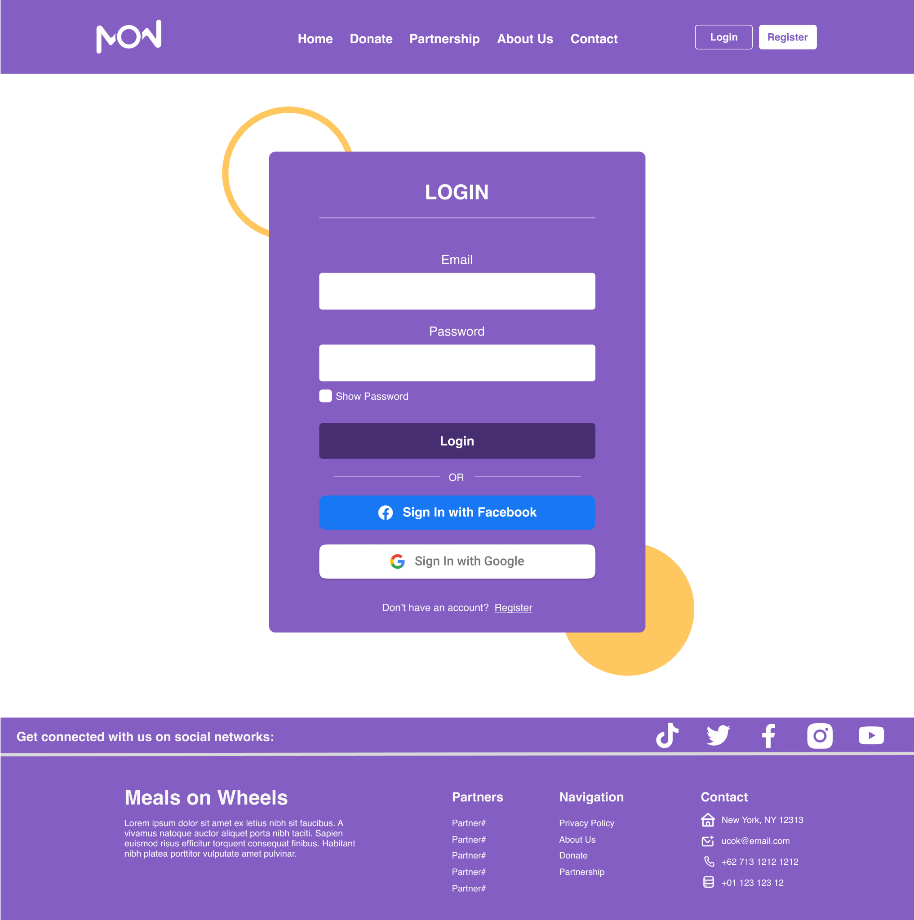

Request Partnership Page

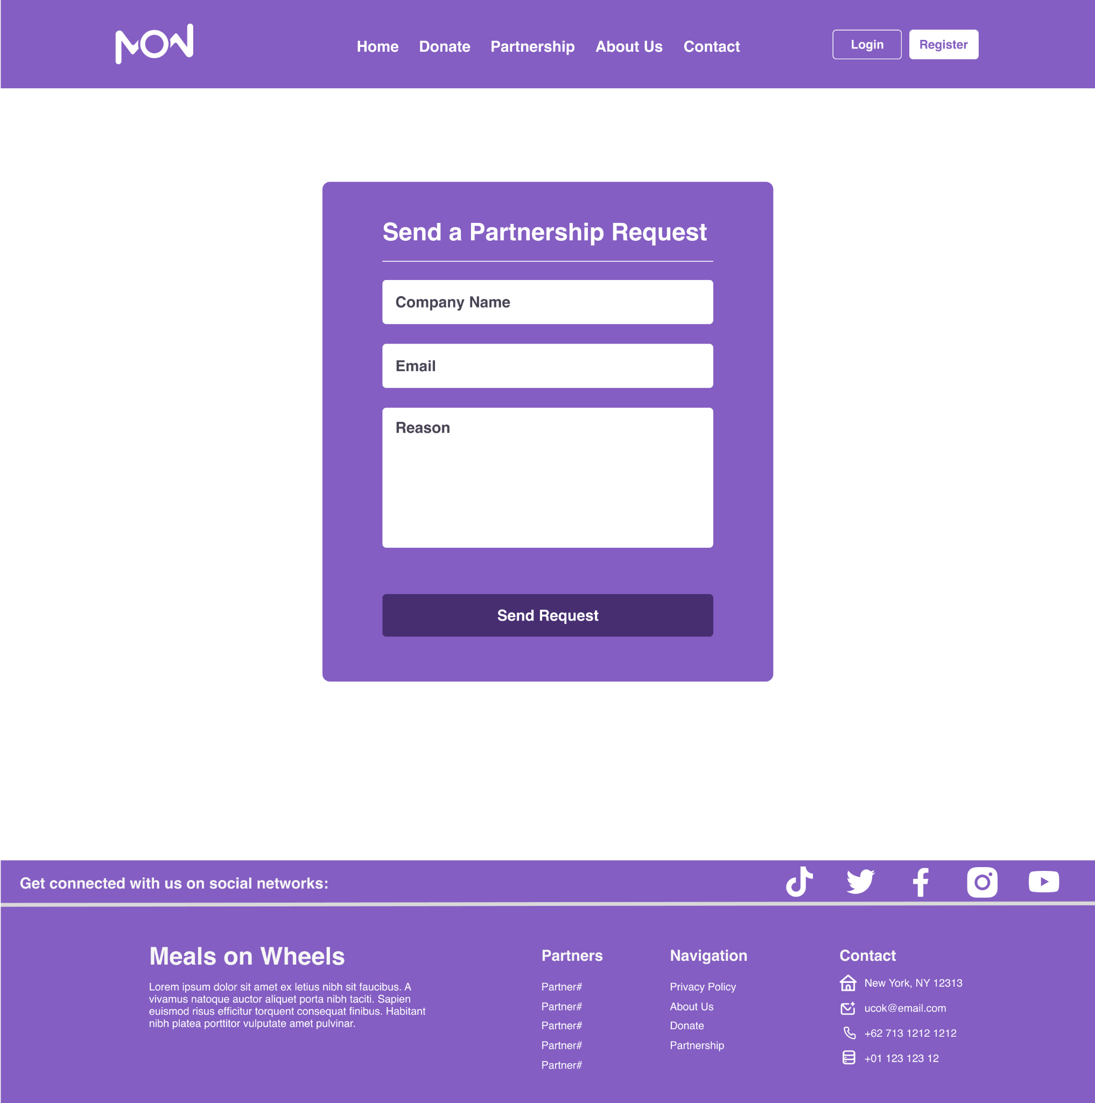

Fundraising Page

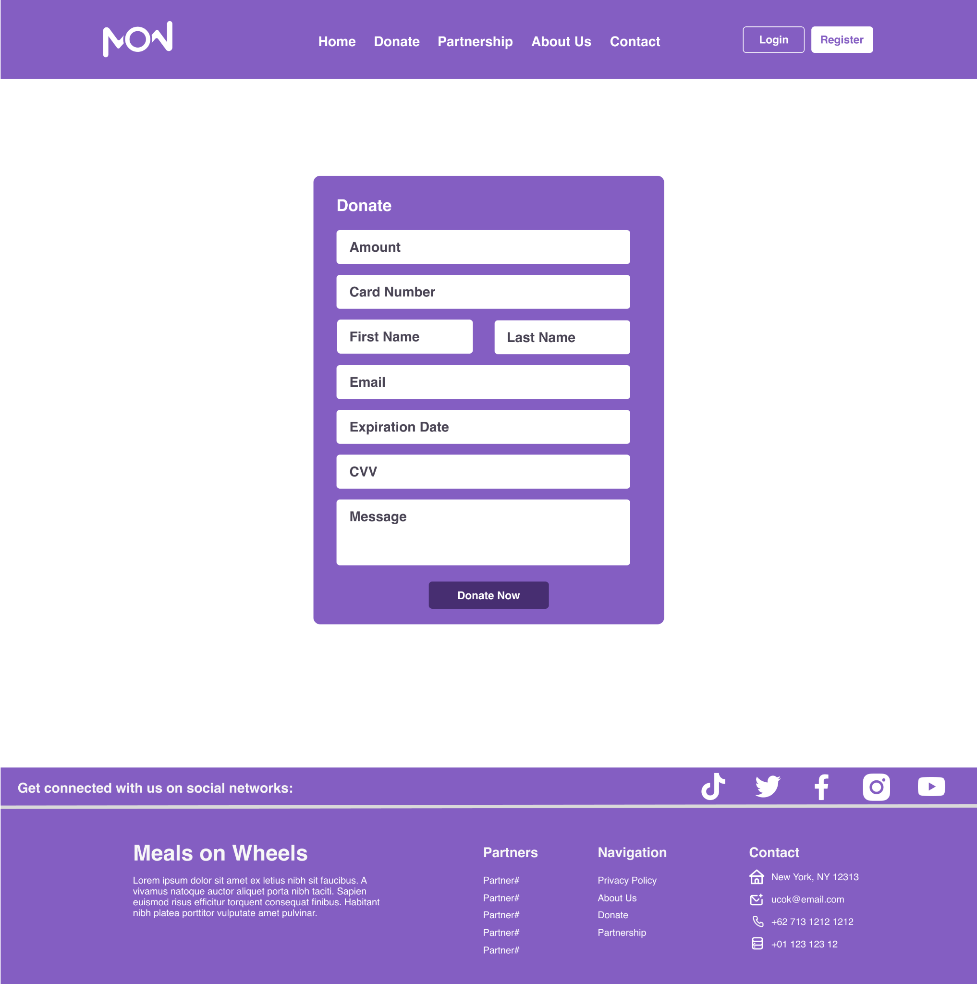

About Us Page

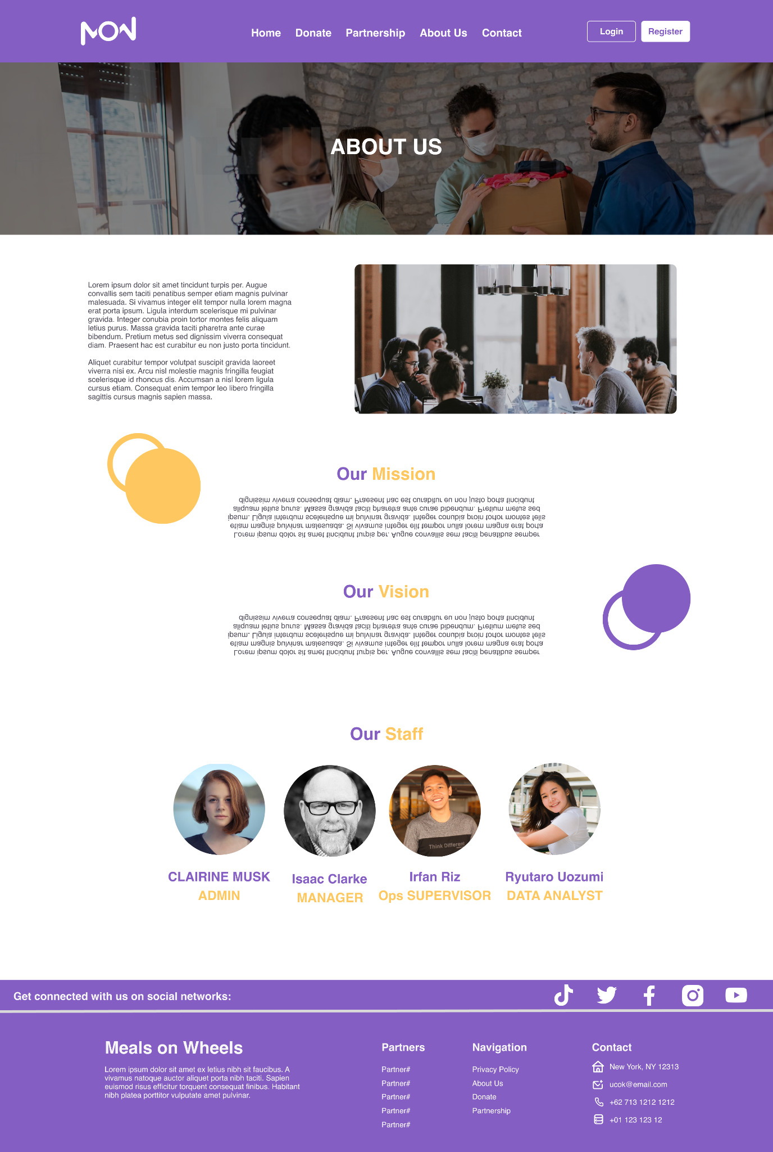

Contact Us Page

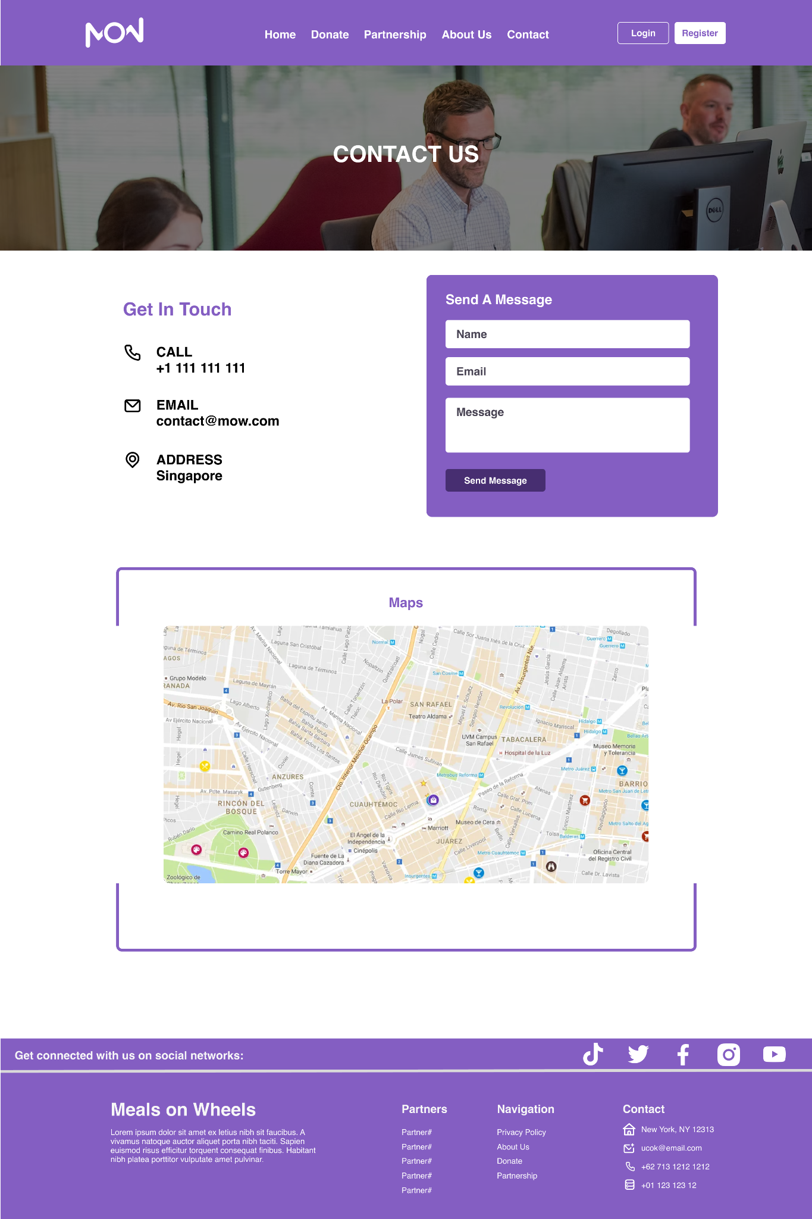

Terms & Condition Page

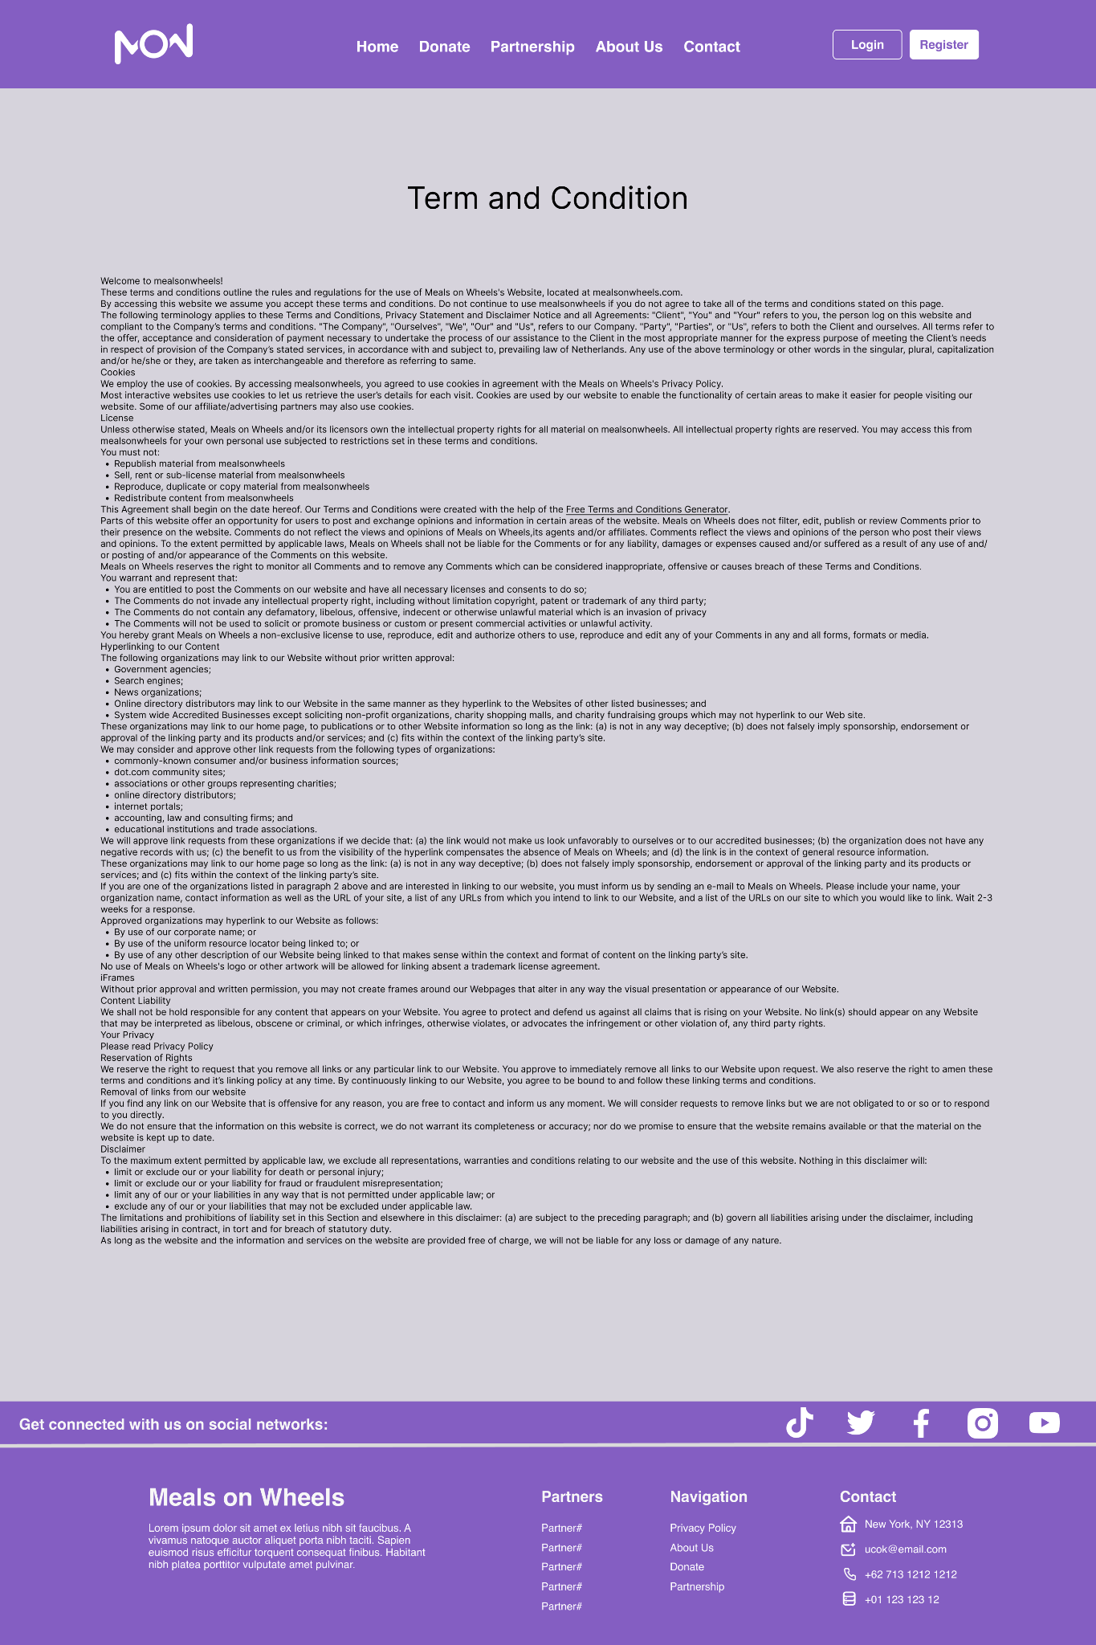

Member: Homepage

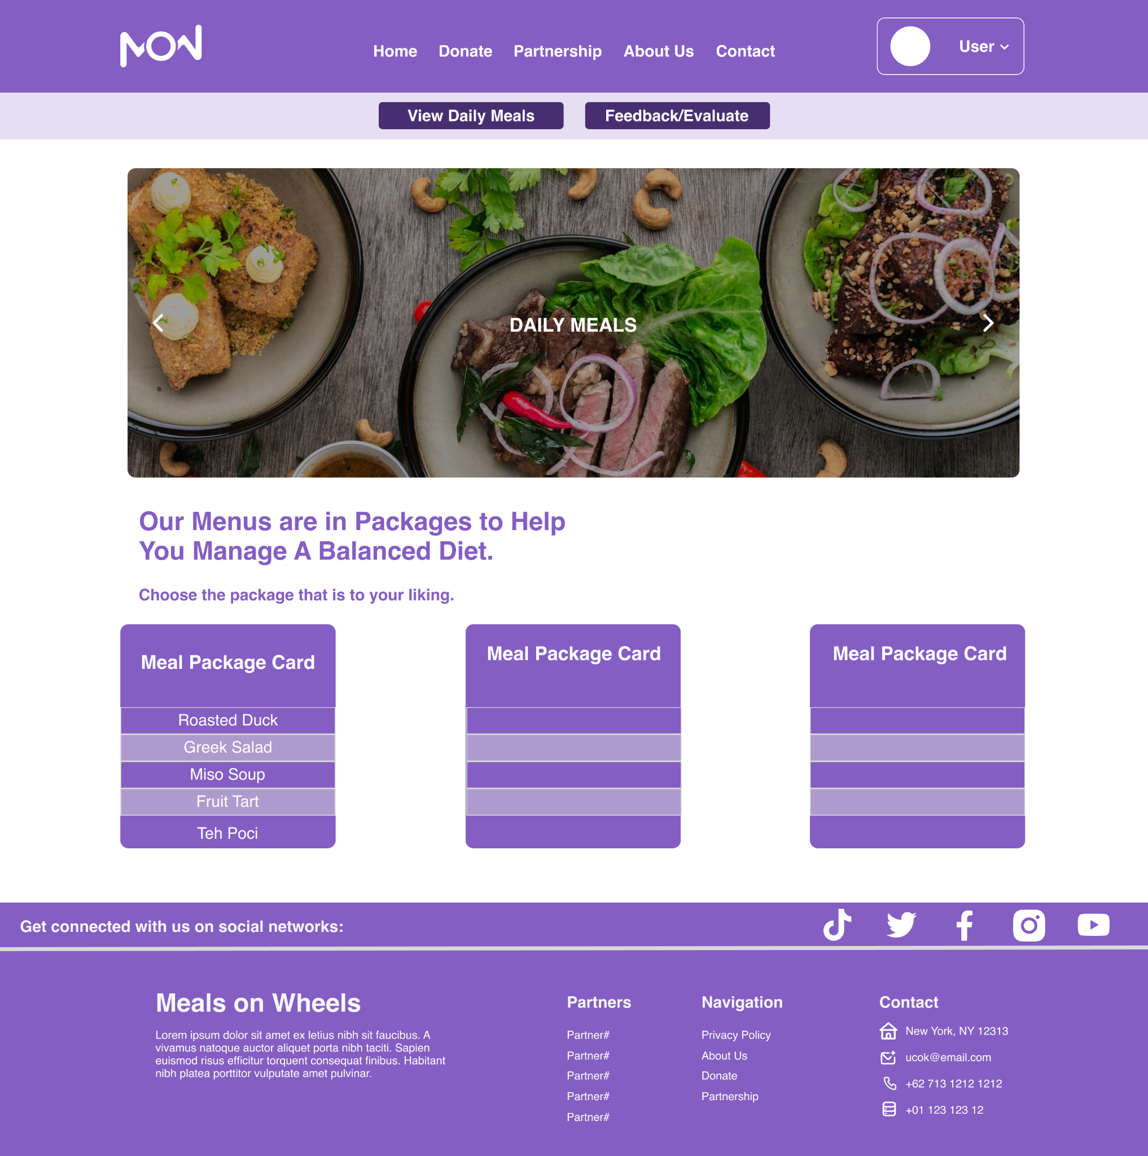

Member: Meal Package Detail

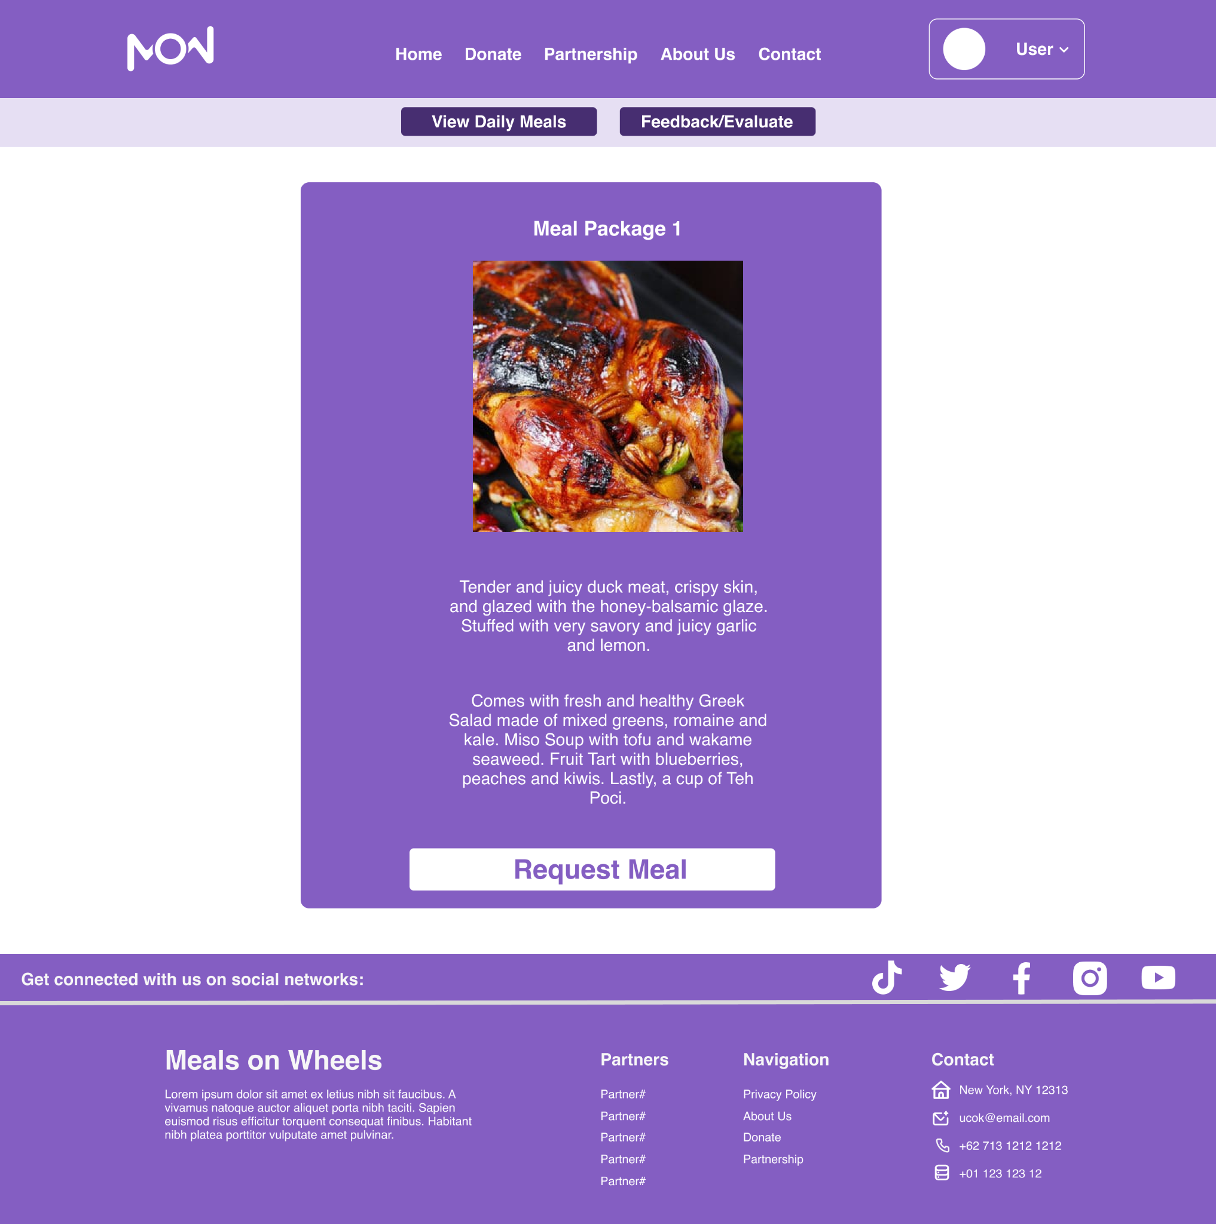

Member: Feedback & Evaluation

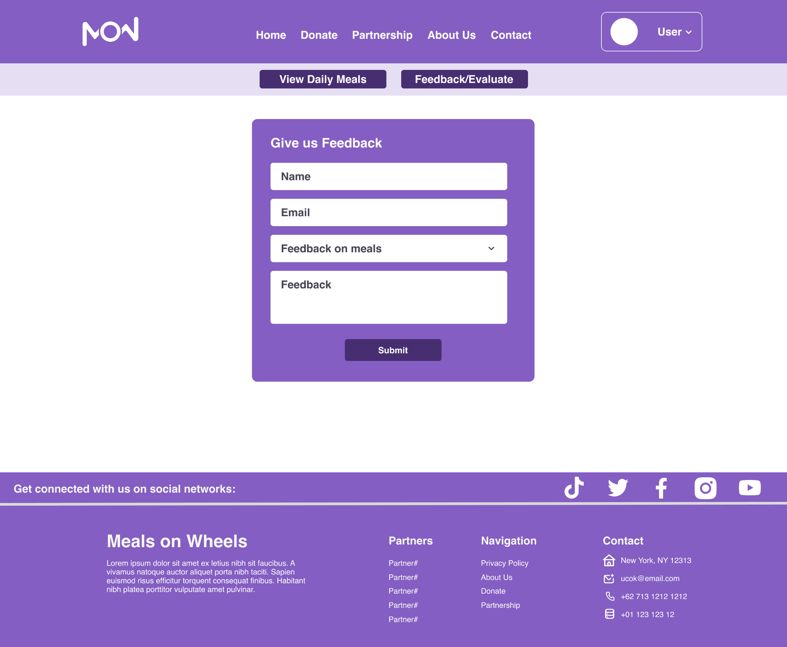

Driver: Homepage

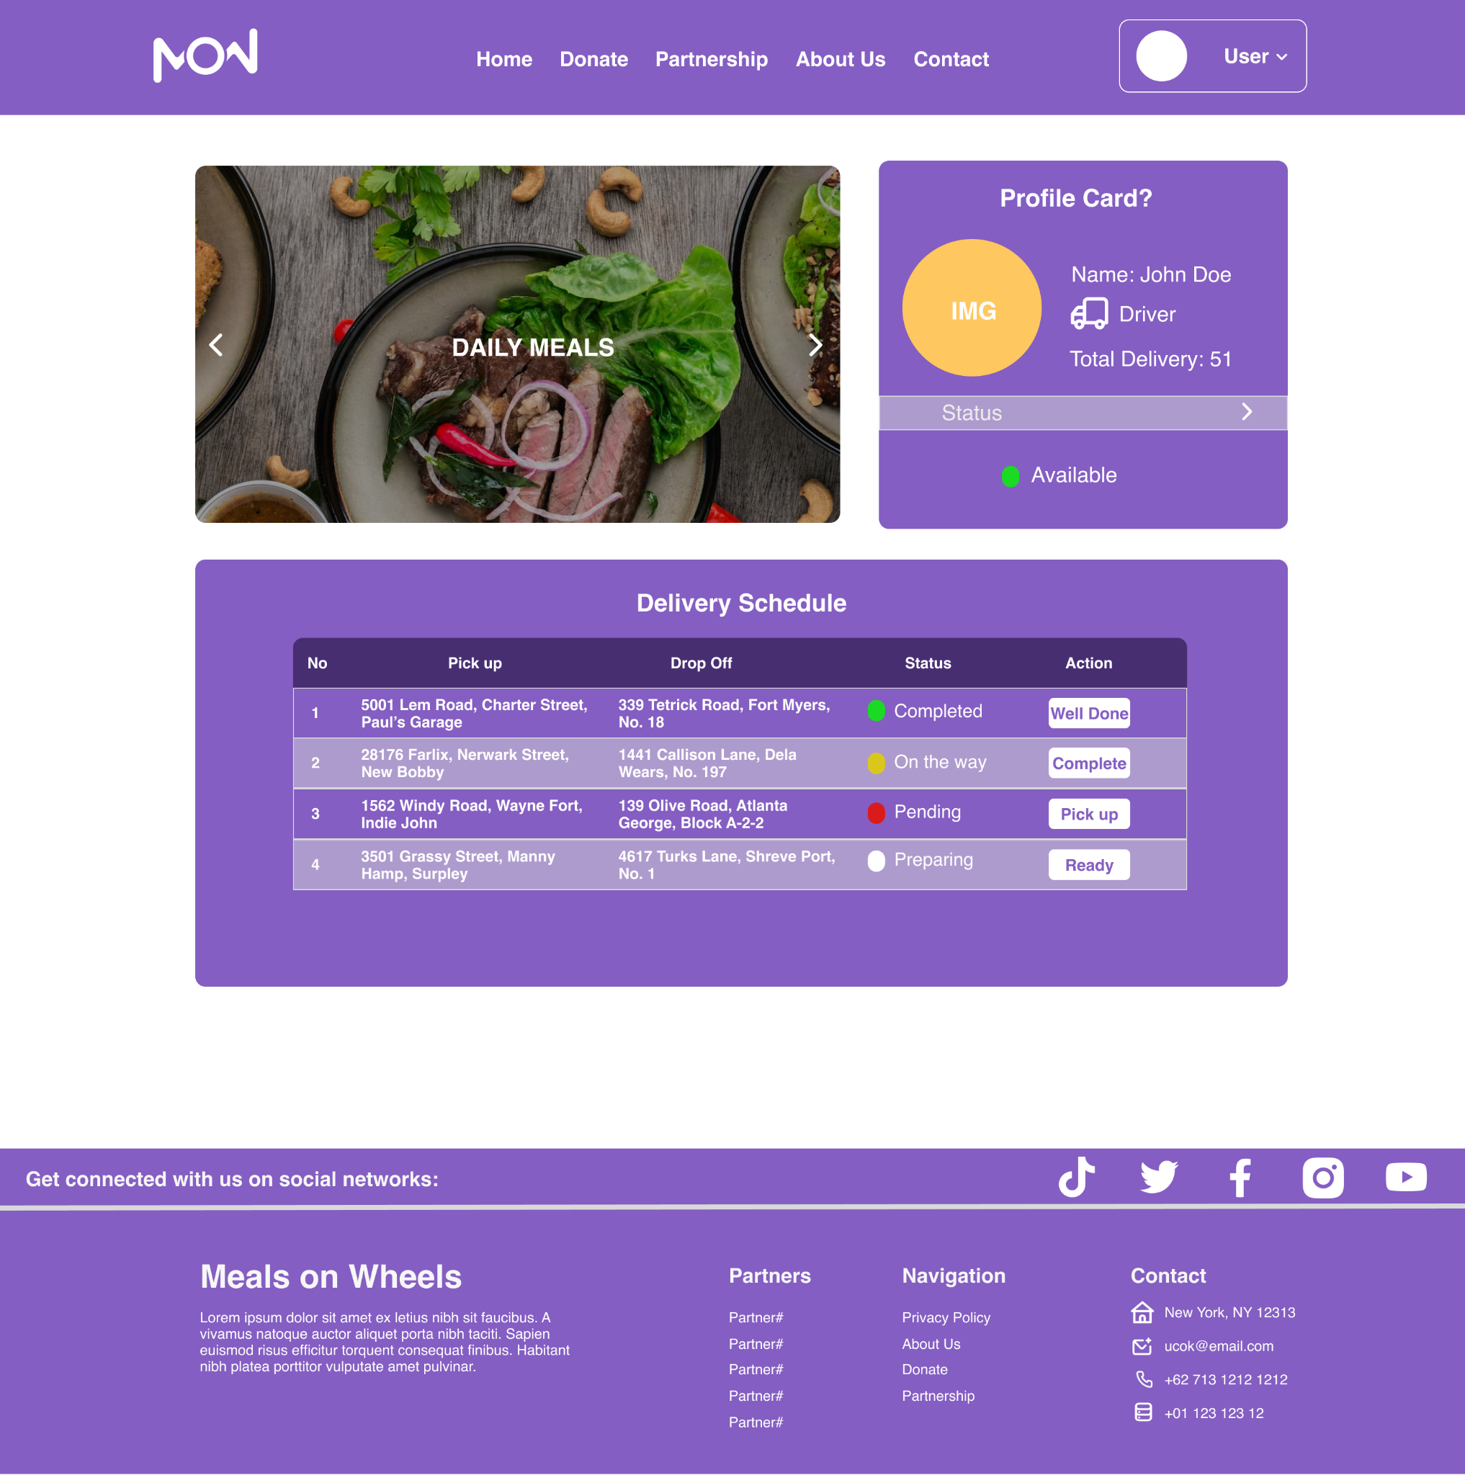

Caregiver: Homepage

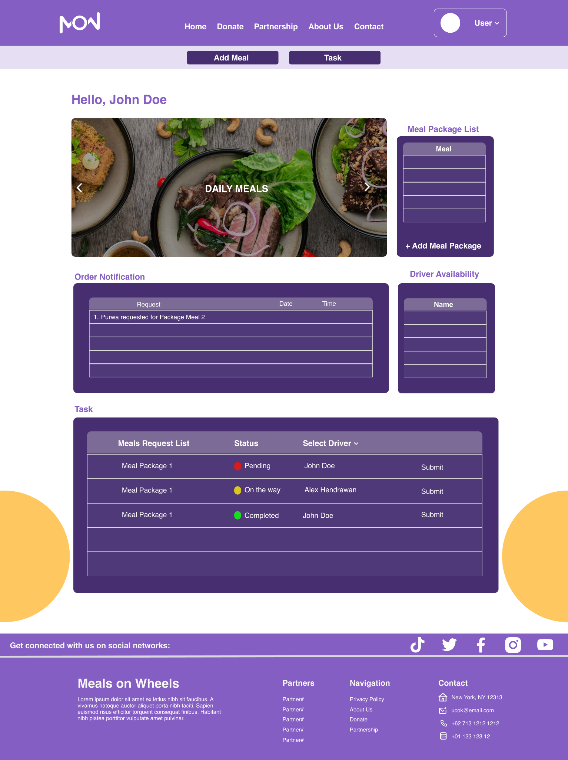

Caregiver: Add Meal Popup

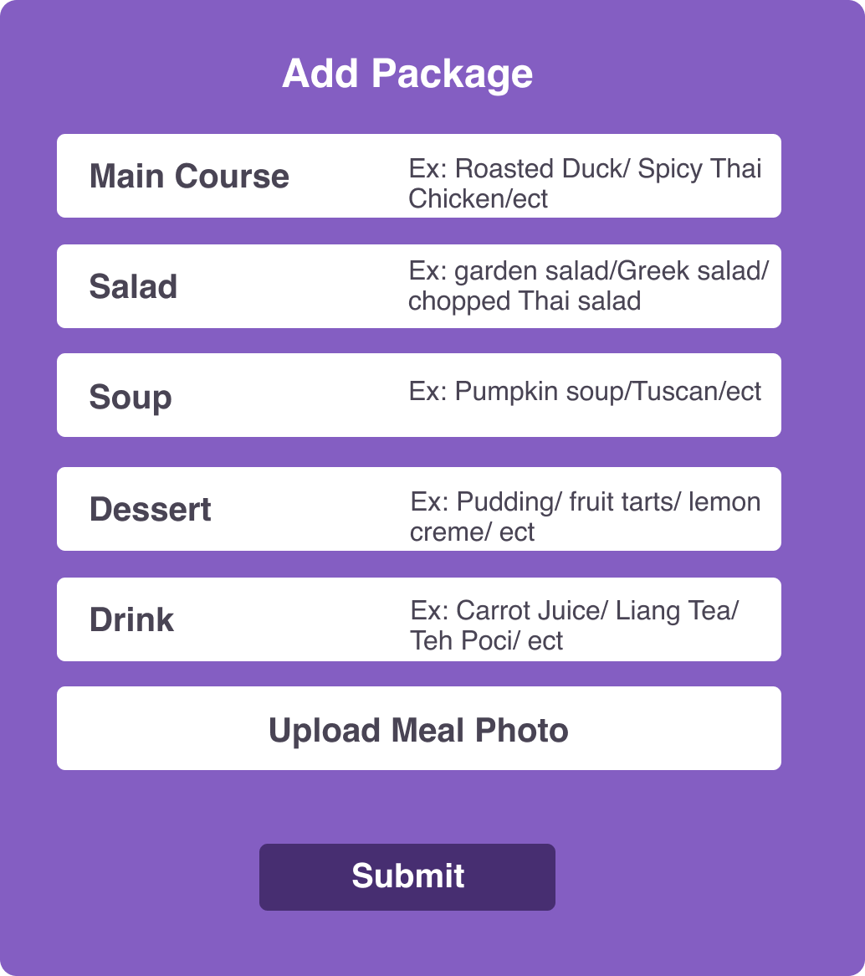

Admin: Homepage

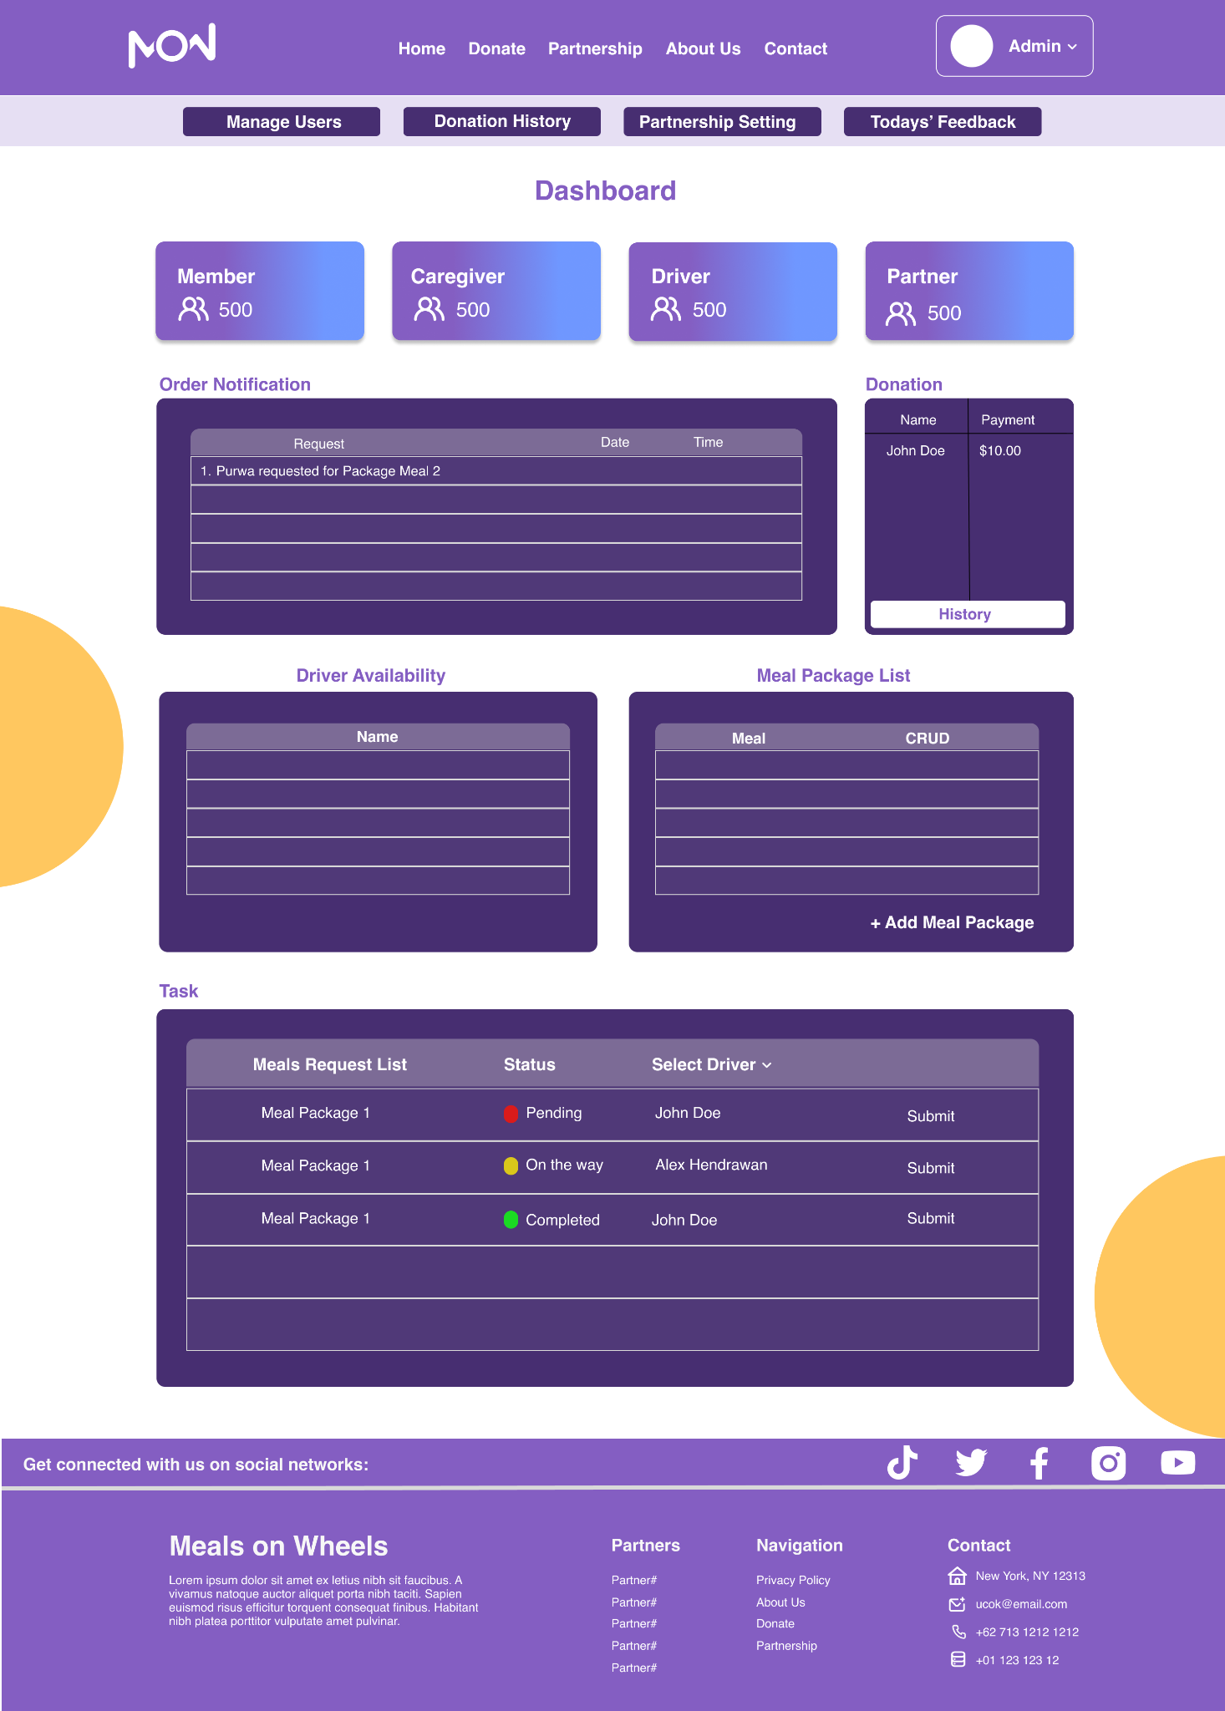

Admin: Donation Setting

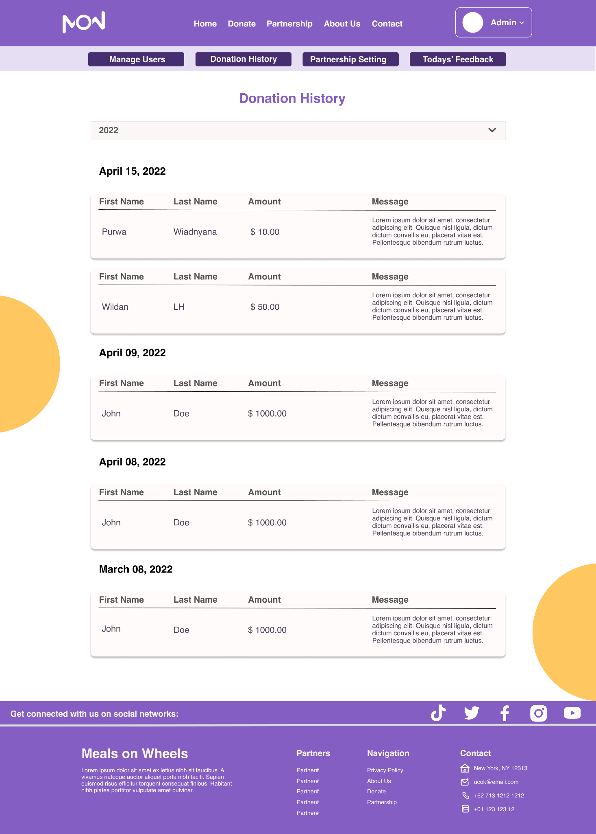

Admin: Partnership Setting

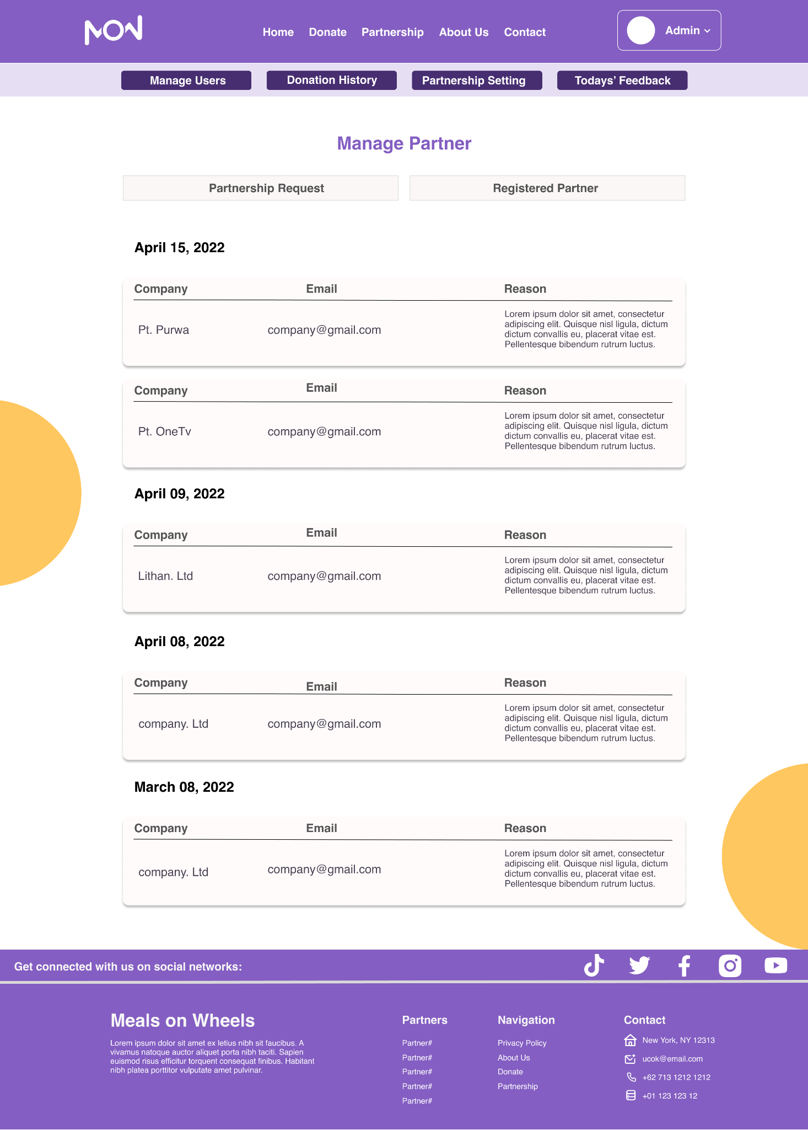

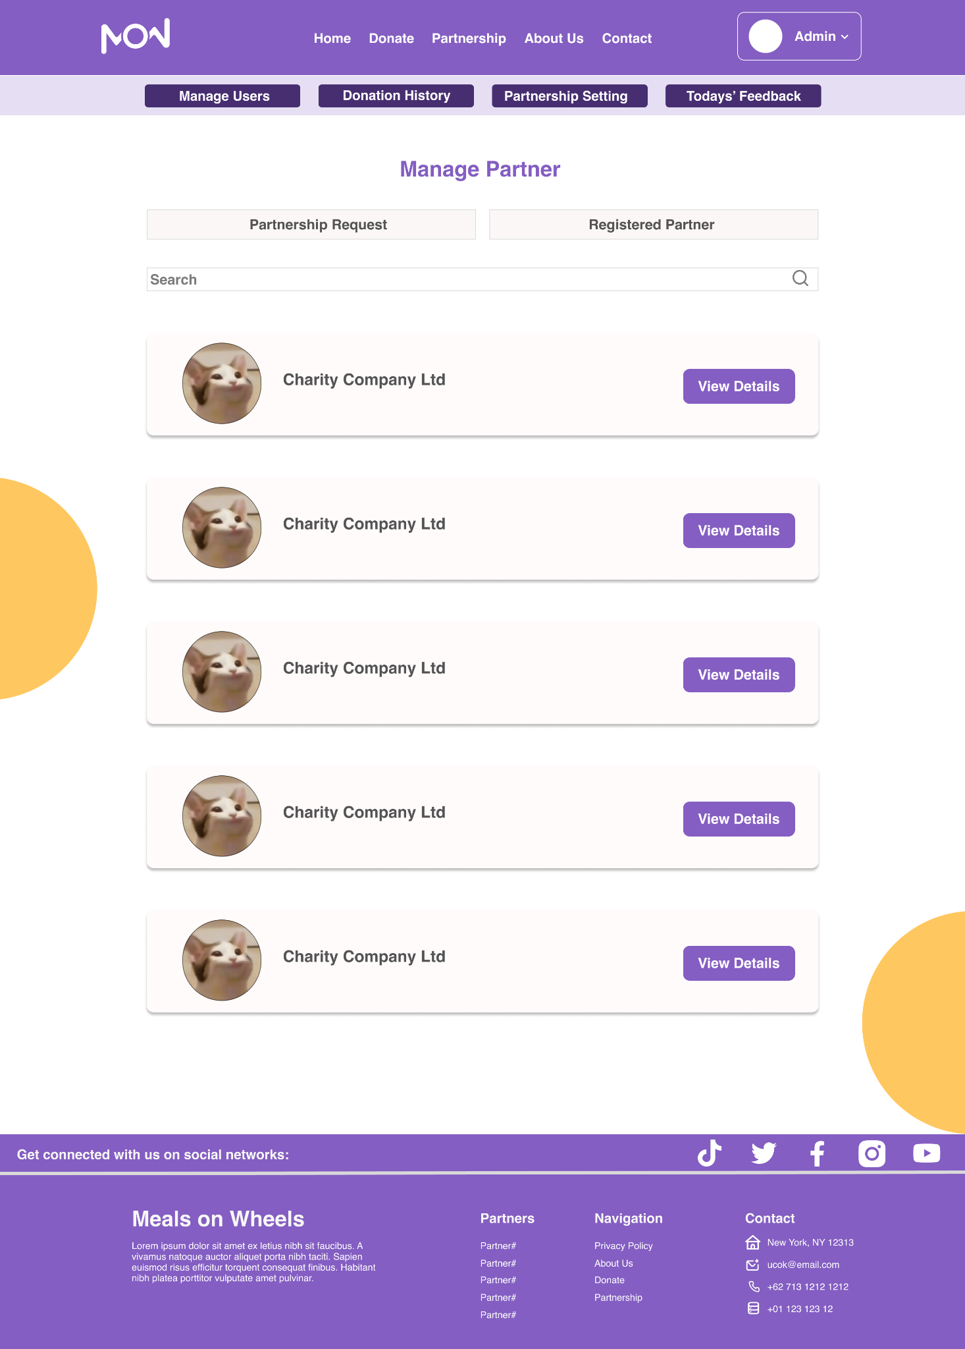

Admin: Manage All User Page



Admin: Today Feedback Popup & View Partner Details Popup

